3/14/2026
Livhuwani Singo
ST10526881
WEBSITE PROJECT PROPOSAL
Web Development
Code: WEDE5020
Table of Contents
Organisation Overview 2
Mission Statement 2
Vision Statement 2
Target Audience 2
Website goals and objectives 2
Goals 2
Key performance areas 3
Current Digital Footing 3
Strengths and Weaknesses 3
Features and functionality 4
Design and User Experience 4
Colour Scheme: 4
Typography 4
Layout and Design 5
Technical Requirement 5
Domain Registration 5
Web Hosting 5
Programming Languages and frame work 5
Timeline and Milestones 5
Budget 6
References 6

Organisation Overview
MOOVE MZANSI
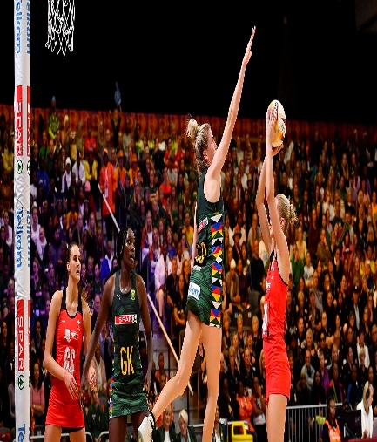
Moove Mzansi, established in 2023, is a non-profit organisation that aims to help the community stay active and introduce diverse sporting codes. It was born because of the worrisome reliance of the modern generation on their digital devices and lack of social skills. By offering a blend of indigenous games and professional sports, Moove Mzansi creates a space where physical interaction builds character and companionship.
Playing outdoors can improve the development, mental, physical and emotional health of individuals of all ages. Many studies indicate that outdoor engagement enhance the social skills, concentration and school readiness (Unief, 2025).

Mission Statement
Moove Mzansi aims to foster a holistic development of all youth and the elderly through constant movement and physical engagement.

Vision Statement
To ignite a movement culture that inspire people (especially the youth) to start moving again.

Target Audience
Moove Mzansi serves as a bridge between the youth and their elders. Children and adolescence, ages 5-18, will benefit from learning how their elders (30-45+) used to do sports while the youth can give a spin of adventure to the old.

Website goals and objectives

Goals
- Credibility- Digital headquarters for Moove Mzansi, providing information regarding our founding, leadership team and current partners.
- Digital Presence- To capture community interest through an organic search. Given our lack of a strong social media presence, the website acts as a central hub where all can participate through Google inquires.
- Operational Growth{sign-ups}- Registration through online forms and increase volume of yearly enrolment.
- Partnership with investors- Platform where potential investors and corporate sponsors may review our impact and initiate funding.

Key performance indicators areas
- User Engagement- Increase average time spent on content pages and the about us page. The interaction with the different sports and clubs offered by the organization.
- Growth and Visibility – Monthly growth in unique website visitors and organic search ranking for keywords Mzansi based sports and activities hubs.
- Technical Health – maintaining the page loading time of under 5 seconds and ensuring 100% mobile responsiveness for users with various devious devices and with varying networks.
- Social Advocacy – The frequency in which the content of the page is shared, testimonials of the impact of the organisation is received. The recommendations of both current and past participants to boost the reviews of the organisation.

Current Digital Footing
Currently, Moove Mzansi does not have an official website presence. This creates a reliance on manual inquires. While the organisation has built a strong reputation offline, there is a significant group that are being redirected to competitors of which Moove offers the same services.

Strengths and Weaknesses
STRENGTHS | WEAKNESS
- Personal Connection- They have established a strong offline reputation. | - No digital presence- Lack of official website and a poor media footprint.
- Unique service offering- A rare blend of traditional games and professional sports | - Manual Inefficiencies- High reliance on manual inquiries and physical sign-ups.
- Multi-generational Appeal- acts as a bridge to the youth and the elderly. | - Competitive disadvantage- Potential participants are redirected to competitors with better digital visibility.
- Established Identity- clear vision and mission, established since 2023. | - Information Silos-Vital organisational data (History, Leadership. Partners) is not easily accessible to the public and investors.

Features and functionality
- Home page-logo, hero image, introduction and navigation menu
- Sports and Games – Tennis, Diketo, Athletics, Basket Ball, Chess, Mogusha, etc
- Events - Running and Walking Monday, Sporting tournaments, team buildings
- News – Newsletters, Organisation News, Sportings News
- Prices - Membership Packages, Once-Off use of facilities, Training Packages
- About us - Organisation History, Vision and Mission, Founders and Team Members
- Contact – Contact information, Sign-up/enquiry forms, Location of Organisation, Volunteer application

Design and User Experience

Colour Scheme:

Figure 1: Colour Palette

Typography
The website will prioritise readability and good navigation through clean imagery and minimal styling. We will utilize Cascading Style Sheet (CSS) to implement sophisticated visual layout and ensure well-integrated aesthetic across the entire platform. Furthermore, images will be well sized to establish a clear visual hierarchy, to guide the user’s attention to the most important content.

Layout and Design

Figure 2: Site Map

Technical Requirement
Domain Registration:
This website will be registered with a .co.za extension. This will ensure a localised digital presence, improve search relevance and build trust with the target audience.
Web Hosting:
The platform used will be Truehost. This provider is selected for its high performance infrastructure, which will ensure optimal loading speed for all users.
Programming Languages and framework:
- Html5-The skeletal structure of the website. It defines the content of the page.
- CSS- The styling of the website. It is the visual presentation of the website and enures that the website looks professional on all devices.
- JavaScript- The functionality of the website. It is what makes the website perform specific actions.

Timeline and Milestones
Phase 1: Research and Analysis
Duration: 2 Days
Conduct an audit of the organisations current digital presence and identify operational needs. Document the specific impact the business faces from their lack of a centralised website.
Phase 2: Proposal and feature definition
Duration: 3 Days
Develop a formal website proposal highlighting the competitive advantages of a digital transition. This phase includes a SWOT analysis and a detailed roadmap of recommended feature.
Phase 3 – Development and content integration
Duration: 1 Month
Create an html website, and integrate all organisational requirements identified in Phase 1
Phase 4: Testing and quality assurance
Duration 3-5 Days
Ensure that the website has good response on all mobile devices. Verify that all forms actually work and check for any broken link.

Budget
BUDGET | PRICES
Website build | R10000
Domain | R3000
Hosting | R2000
Images and graphics | R5000
Maintenance and Security | R4000
TOTAL | R24000

References
Hunt, C., 2026. Color Palettes for designers and artists. [Online]
Available at: https://colorhunt.co/
[Accessed 11 March 2026].
Unief, 2025. The importance ofoutdoor play (and how to support it). [Online]
Available at: https://www.unicef.org/eca/stories/importance-outdoor-play-and-how-support-it
[Accessed 11 March 2026].

